|  |  |  |  |  |  |  |  |  |  |  |  |
| --- | --- | --- | --- | --- | --- | --- | --- | --- | --- | --- | --- |
| **Project Name: demo.opencart.com** | | | | | | | | | | | |
|  | | | | | | | | | | | |
| Bug ID | | 008 | | | | | Reporter | | | Kirill Brezhniev | |
| Test-case ID | |  | | | | | Position Reporter | | |  | |
| Description | | No success text is displayed after sending a message | | | | | Submit Date | | | 20.11.20 | |
| URL | | https://demo.opencart.com/index.php?route=information/contact/success | | | | | Release Version | | | OPENCART.CMS 2.1.0.2 | |
| Priority | | high | | | | | Environment | | | Opera 72.0.3815.320 | |
| Severity | | moderate | | | | | Assign to | | |  | |
|  | | | | | | | | | | | |
| Pre-conditions | | | Contact page is opened | | | | | | | | |
| Dependencies | | |  | | | | | | | | |
| Steps to reproduce: | | | | | | | | | | | |
| N | Action | | | Inputs | Expected Output | Actual Output | | Screen  shots | Comments | |
| 1 | Input message in the “Enquiry” field | | | /*any text message, more than 10 symbols*/ | Text is inputted in the field | Text is inputted in the field | |  |  | |
| 2 | Click on the “Submit” button | | |  | Success message is displayed | Success message is not displayed | | Bug8 |  | |

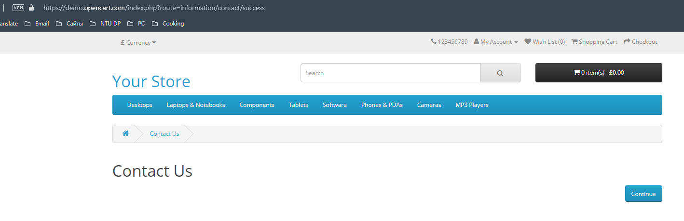bug8